Traffic control reduces crash severity for drivers, but not for people on foot
Road user vulnerability and the road environment in New Zealand, 2006–2025

INFO634 — Data Analytics & Business Intelligence
Group Project · Semester Two 2026 · Lecturer: Dr Pan Zheng
Group 21
Name | Student ID
Md. Arif Hossain | 32297506
Aungshuman Paul | 52160855
Han Sun | 83528404
Nicholas Leppik | 52467507
Emily Leppik | 74841813

Data: New Zealand Crash Analysis System (CAS), NZ Transport Agency Waka Kotahi
Analysis in R · Maps and dashboards in Tableau Desktop

Table of Contents
 | Section | Page
1 | Executive summary | 3
2 | Background and business problem | 4
3 | Related work | 4
4 | Research questions | 5
5 | The data | 5
6 | Preparing the data | 6
7 | Exploratory analysis | 6
8 | Statistical testing | 11
9 | Logistic regression | 11
10 | Feature selection | 14
11 | Classification models | 15
12 | Discussion | 19
13 | Recommendations | 21
14 | Limitations and assumptions | 22
15 | Conclusion and future work | 23
16 | References | 23
A | Appendix A — Tableau dashboard | 24
B | Appendix B — full R code | 25
C | Appendix C — software and files | 34
D | Appendix D — glossary | 34

1. Executive summary
When a crash happens, how badly someone is hurt depends partly on the road itself: the traffic control at the site, the speed limit, the road type and the surface. This project asked whether that protection reaches every road user equally.
It does not. Using 155,270 New Zealand crashes from 2021 to 2025, we found that traffic control makes a large difference for people in cars and on motorcycles, and almost no difference for people on foot. Car-only crashes are serious or fatal 2.1% of the time at traffic signals and 5.7% of the time where there is no control. For pedestrians the same two numbers are 23.6% and 25.9% — close to identical. The difference between road users is statistically significant (likelihood-ratio chi-square 49.2 on 18 degrees of freedom, p < 0.001) and survives adjustment for eleven other road and environment variables.
We then extended the analysis back twenty years, to 2006. The gap is not new. It appears in every five-year period, it is significant every time, and it is widening. Over those twenty years the number of serious and fatal crashes fell 9% for car occupants and 12% for cyclists, but rose 17% for motorcyclists and 4% for pedestrians. We confirmed the trend is not caused by changes in crash reporting by repeating the whole analysis on injury crashes only.
Looking year by year inside the recent window adds a second message. Total reported crashes fell 15% between 2021 and 2025, but 95% of that fall was in non-injury crashes. Serious and fatal crashes stayed at about 2,300 a year throughout. Crashes involving vulnerable road users did not fall at all, so their share of all crashes rose from 10.8% to 12.8%. A falling crash count is therefore not evidence that the roads are getting safer for the people most at risk.
Three models were compared. Logistic regression scored an AUC of 0.760, a random forest 0.745 and a decision tree 0.673. Since the simplest model performs at least as well as the others, it is the one we report.
What this means in practice. Adding traffic signals to a dangerous site protects drivers. It does not protect people walking. Pedestrian safety needs lower speeds and physical separation instead. And because serious crashes involving vulnerable road users are spread across 3,041 separate one-kilometre squares — with the worst 100 squares holding only 15.3% of them — fixing a handful of bad intersections cannot solve the problem.

1.1 The findings in plain numbers
The main result can be stated without any statistics. Figure 1 shows, for each kind of road user, how many out of every 100 crashes end in serious injury or death at traffic signals and at sites with no traffic control.
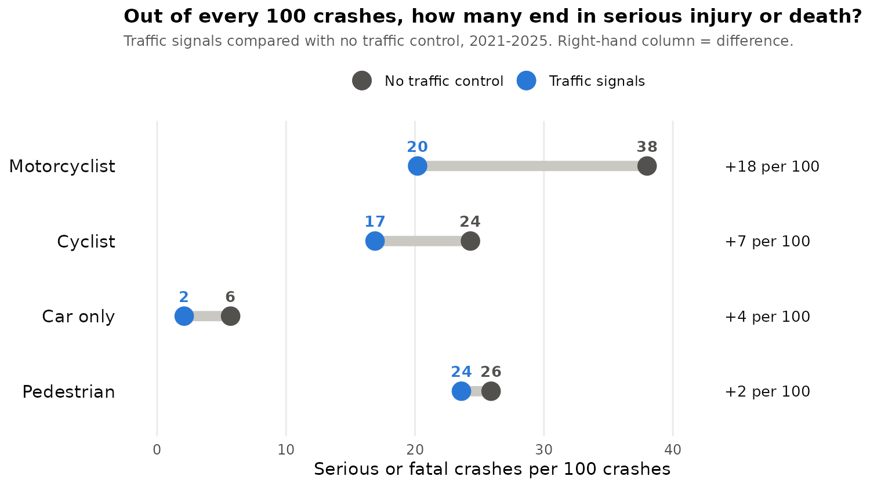
Figure 1. Serious or fatal crashes per 100 crashes, at traffic signals and with no traffic control, 2021–2025.
Road user | At traffic signals | No traffic control | What this means
Car only | 2 in 100 | 6 in 100 | Signals cut serious outcomes to about a third
Motorcyclist | 20 in 100 | 38 in 100 | Signals roughly halve serious outcomes
Cyclist | 17 in 100 | 24 in 100 | Signals cut serious outcomes by about 30%
Pedestrian | 24 in 100 | 26 in 100 | Almost no difference — and none at all once road conditions are taken into account (Section 9.3)
Table 1. The main finding as natural frequencies.
Put another way: at a site with no traffic control, a car-only crash is 2.7 times as likely to be serious as at signals. For a motorcyclist it is 1.9 times, for a cyclist 1.4 times, and for a pedestrian only 1.1 times.
One point needs care. These numbers describe what happens once a crash has occurred. They do not tell us whether signals stop pedestrian crashes from happening in the first place, because nobody records how many people cross at each kind of site. Section 14.1 explains why this does not change our conclusion, and what it leaves open.

2. Background and business problem
Road safety is a major public issue in New Zealand. Every year hundreds of people are killed and thousands are seriously injured, at a large human and economic cost. Central and local government spend substantial sums on road improvements, and the most common improvement at a dangerous intersection is better traffic control, usually signals.
These decisions are normally justified by crash counts. A location with many crashes is treated as a problem site, and the standard response is to add control. The unstated assumption is that control helps everyone who uses that location. Our project tests that assumption.
The people with the most to lose are those with no protective structure around them: pedestrians, cyclists and motorcyclists. Throughout this report we call them vulnerable road users. If the road environment protects them less well than it protects drivers, then investment guided by total crash counts will systematically under-serve them, and the gap will not show up in the counts themselves.
The business question. Which road-safety interventions actually reduce harm, for whom, and where should a council or NZTA spend to reduce the most serious injuries? Answering this requires more than counting crashes. It requires modelling severity, and letting the effect of the road differ by the kind of person involved.

3. Related work
Research on crash severity is well established, and two strands are directly relevant to our work.
Machine learning on vulnerable road users. Komol et al. (2021) analysed 21,158 crashes involving vulnerable road users in Queensland, Australia, between 2013 and 2019, using k-nearest neighbour, support vector machines and random forest. Random forest performed best, reaching 72.3% test accuracy for motorcyclists and 67.2% for pedestrians. They found posted speed limit among the most important predictors, and reported that motorcyclists face substantially higher severity than other groups, followed by pedestrians. Our results agree on both points: motorcyclists have the highest severity rate in our data at 33.8%, and speed limit is the strongest road-related predictor in our models.
Infrastructure and traffic control. Tanishita, Sekiguchi and Sunaga (2023) studied 86,406 pedestrian–vehicle crashes in Japan between 2019 and 2021 using bias-reduced logistic regression, separating intersections from non-intersections. They found stop signs and three-light traffic signals reduced fatality risk, while flashing signals and pedestrian-controlled signals increased it. This is the closest published work to ours in design. The important difference is that their study models pedestrian crashes alone, so it cannot compare the effect of control between road users. That comparison is our contribution.
Speed and severity in New Zealand. Chipperfield and Turner (2024) analysed CAS data and showed that the relationship between speed and casualty outcome varies sharply by crash type, with head-on crashes rising from a severity index of 56 at 60 km/h to 89 at 100 km/h, while single-vehicle off-road crashes depend more on roadside hazards than on speed. Their finding that the speed effect is not uniform across crash types is the same kind of result we report for road-user type.
Data quality. Alsop and Langley (2001) documented under-reporting of crash victims in New Zealand police data, which remains the main known weakness of CAS and is discussed in Section 16.
Where our work differs. Most published studies fit main effects: road-user type and traffic control enter the model as separate additive terms. Fitting them as an interaction is what exposes the difference between groups. We also extend the analysis over twenty years and include a control for changes in reporting practice, which lets us say not only that a gap exists but that it is growing.

4. Research questions
- After accounting for the road environment, how much more serious are crashes involving vulnerable road users?
- Does traffic control reduce crash severity equally for all road users? (main question)
- Does the posted speed limit affect each road-user group in the same way?
- Are serious crashes involving vulnerable road users concentrated in a few locations, or spread out?
- Can crash severity be predicted, which factors matter most, and does a machine learning model outperform a simple one?
- Have the answers to these questions changed over twenty years?

5. The data
We used the Crash Analysis System (CAS) open dataset published by NZ Transport Agency Waka Kotahi. The full download holds 705,609 crashes from 2006 to mid-2026 across 72 columns, covering location coordinates, road type, traffic control, number of lanes, road surface, weather, light conditions, speed limit, the vehicles and people involved, and the severity of the outcome.
Part | What we used
Part 1 — main analysis | 2021 to 2025. Five complete years, 155,270 crashes. 142,076 of these have no missing values on the twelve variables we model.
Part 2 — twenty-year check | 2006 to 2025. Twenty complete years, 691,036 crashes.
Excluded | 2026, because the year is incomplete and only 14,573 crashes are recorded so far.

Why we use data older than five years. The project instructions ask for a justification if older data is used. Ours is that Part 2 asks whether the pattern has changed over time, and that question cannot be answered with five years of data. Part 1, which carries all the main models, uses recent data only. The two parts are reported separately throughout so it is always clear which window a number comes from.
Data quality over time. Before using the twenty-year window we checked that the variables we need are recorded consistently. Traffic control, road character, road surface, lanes, speed limit and coordinates are close to 100% complete in every five-year period back to 2006, so the long window is usable.

6. Preparing the data

6.1 The outcome variable
CAS records four severity levels: fatal, serious, minor and non-injury. We combined fatal and serious into one group and minor and non-injury into the other, giving a binary outcome. In 2021–2025, 7.58% of crashes were serious or fatal. We kept the fatal-only rate as a separate descriptive measure.

6.2 Labelling the road user
One crash can involve more than one kind of road user — a truck and a motorcycle, for example. A single label per crash was needed, so we used the most vulnerable person involved, in this order: pedestrian, then cyclist, then motorcyclist (including mopeds), then car only. A crash involving both a truck and a motorcycle is therefore counted as a motorcyclist crash, and heavy-vehicle involvement is carried separately as its own variable so that information is not lost.

6.3 Blank values in the road-user columns
The pedestrian column is blank in about 96% of rows and is never written as a zero. We checked this in every five-year period from 2006 and the pattern is identical throughout, which confirms that blank means “no pedestrian involved” rather than “not recorded”. We therefore set blanks to zero for all six road-user columns.

6.4 Grouping and cleaning
- Traffic control was grouped into four types: traffic signals, give-way sign, stop sign and no control. The specialist categories (pointsman, school patrol, isolated pedestrian signal) are too small to model — under 0.3% of crashes together — and were set to missing. “Unknown” was also set to missing. It is a larger group (3,592 crashes), but 98% of it falls in 2021 and 2022 because of a change in how traffic control was recorded. Section 7.3 describes this and Section 9.4 shows it does not change the results.
- Speed limits were banded into four groups: 40 km/h or less, 50 km/h, 60–80 km/h, and 90 km/h or more. Values below 10 or above 110 were treated as recording errors and set to missing.
- Lanes were banded into one, two, and three or more. A recorded value of zero was set to missing.
- Road features were grouped into standard road, bridge, motorway ramp, over or underpass, rail crossing and other feature.
- Light was grouped into daylight (bright sun and overcast), twilight and dark. Weather was grouped into fine and adverse.
- The intersection column was empty for every row in recent years and was dropped.

6.5 Missing data
Models were fitted on complete cases: 142,076 of 155,270 crashes, keeping 91.5% of the data. We assume the missing values are unrelated to crash severity. The variables with most missing values are light conditions and weather, both under 2%.

7. Exploratory analysis
We start with the five-year picture, one year at a time, before looking at severity by road user, traffic control and speed.

7.1 How many crashes, and how serious
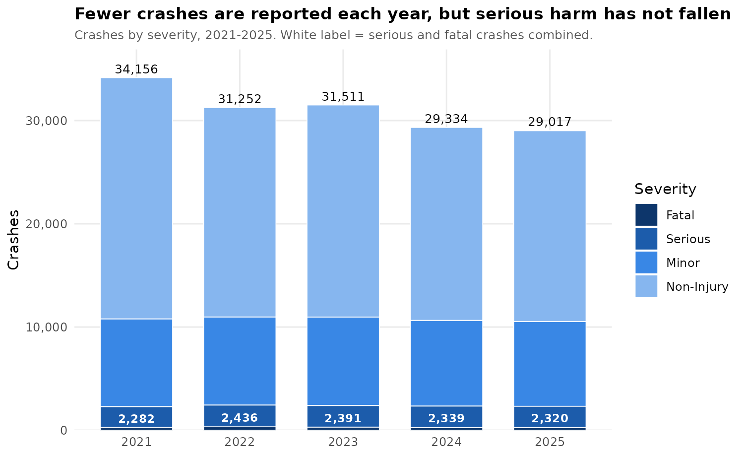
Figure 2. Crashes by severity, 2021–2025. The dark blocks at the bottom are serious and fatal crashes.
Year | All crashes | Non-injury | Minor | Serious | Fatal | Serious + fatal
2021 | 34,156 | 23,369 | 8,505 | 1,995 | 287 | 2,282 (6.7%)
2022 | 31,252 | 20,280 | 8,536 | 2,102 | 334 | 2,436 (7.8%)
2023 | 31,511 | 20,549 | 8,571 | 2,086 | 305 | 2,391 (7.6%)
2024 | 29,334 | 18,689 | 8,306 | 2,090 | 249 | 2,339 (8.0%)
2025 | 29,017 | 18,475 | 8,222 | 2,061 | 259 | 2,320 (8.0%)
Change | −15.0% | −20.9% | −3.3% | +3.3% | −9.8% | +1.7%
Table 2. Crashes by severity and year. The last column shows serious and fatal crashes with their share of all crashes that year.
- Fewer crashes overall. Total reported crashes fell by 15%, from 34,156 in 2021 to 29,017 in 2025.
- Almost all of the fall is in the least serious crashes. Non-injury crashes fell by 4,894, which is 95% of the total fall of 5,139. Minor crashes barely changed (−3%).
- Serious harm is flat. Serious and fatal crashes stayed between 2,282 and 2,436 every year. Because the total shrank, their share rose from 6.7% to 8.0%. That rise comes from the smaller denominator, not from more serious crashes.
- Fatal crashes are down a little. Fatal crashes peaked at 334 in 2022 and have been around 250 a year since.
Why it matters. If success were judged by total crash numbers, 2021–2025 would look like steady progress. Judged by serious and fatal crashes, nothing changed. This is part of why we model severity rather than counts, and it matches the reporting change we control for in Section 12.2.

7.2 Vulnerable road user crashes by year
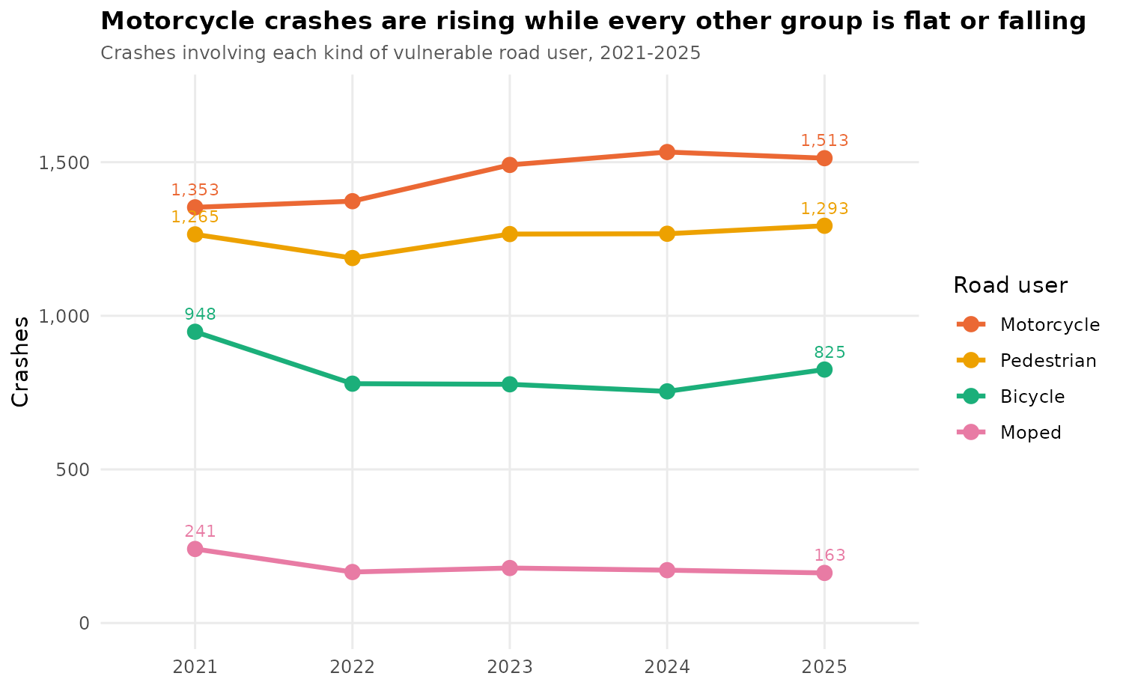
Figure 3. Crashes involving each kind of vulnerable road user, 2021–2025.
Year | Pedestrian | Motorcycle | Bicycle | Moped | Any VRU | Share of all
2021 | 1,265 | 1,353 | 948 | 241 | 3,679 | 10.8%
2022 | 1,188 | 1,373 | 779 | 166 | 3,412 | 10.9%
2023 | 1,266 | 1,491 | 777 | 179 | 3,636 | 11.5%
2024 | 1,267 | 1,533 | 754 | 172 | 3,662 | 12.5%
2025 | 1,293 | 1,513 | 825 | 163 | 3,718 | 12.8%
Change | +2.2% | +11.8% | −13.0% | −32.4% | +1.1% | +2.0 pts
Table 3. Crashes involving each kind of vulnerable road user by year. A crash with two kinds (434 crashes, 2.4%) is counted under both, so the four groups add up to slightly more than “Any VRU”.
- Vulnerable road users did not share in the fall. Crashes involving a vulnerable road user stayed at about 3,400–3,700 a year while all crashes fell by 15%. Their share of all crashes rose from 10.8% to 12.8%.
- Motorcycles are rising. Motorcycle crashes rose by 11.8%, from 1,353 to 1,513. This is the only group that clearly increased, and it matches the 17% rise in serious motorcyclist crashes over twenty years in Section 12.1.
- Pedestrians are flat. Pedestrian crashes were steady at 1,188–1,293 a year.
- Cyclists and moped riders fell. Bicycle crashes fell 13%, with a dip from 2022 to 2024 and a partial rebound in 2025. Moped crashes fell by a third, although the numbers are small.
Note on counting. This view counts every kind of vulnerable road user involved. The models in Sections 9 to 11 instead label each crash by the most vulnerable person in it, and count mopeds as motorcyclists. The two views answer different questions, so their totals differ slightly.

7.3 Traffic control by year, and a change in recording
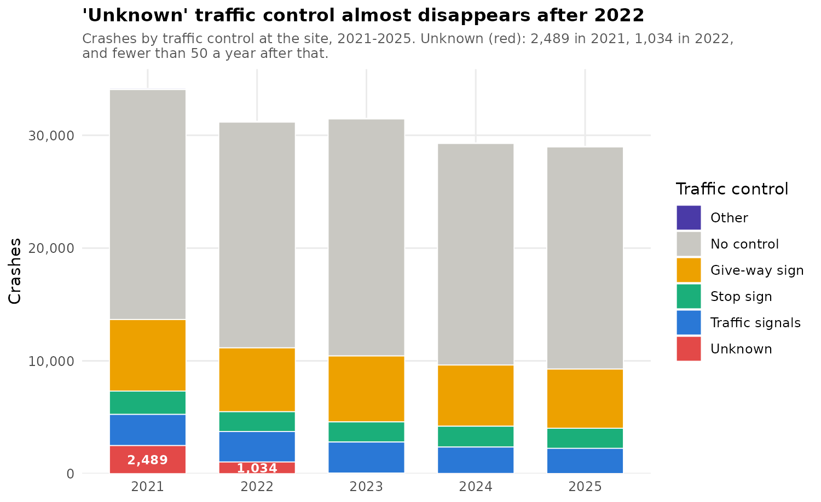
Figure 4. Crashes by traffic control at the site, 2021–2025.
Year | No control | Give-way | Stop | Signals | Other | Unknown
2021 | 20,391 (59.7%) | 6,352 | 2,069 | 2,764 | 91 | 2,489 (7.3%)
2022 | 20,015 (64.0%) | 5,672 | 1,756 | 2,702 | 73 | 1,034 (3.3%)
2023 | 21,019 (66.7%) | 5,858 | 1,785 | 2,754 | 47 | 48 (0.2%)
2024 | 19,654 (67.0%) | 5,428 | 1,848 | 2,343 | 47 | 14 (<0.1%)
2025 | 19,696 (67.9%) | 5,257 | 1,782 | 2,236 | 39 | 7 (<0.1%)
Table 4. Crashes by traffic control and year. Other = pointsman, school patrol and isolated pedestrian signal combined.
- Most crashes happen away from any control. Between 60% and 68% of crashes happen where there is no traffic control at all. Give-way sites account for about 18% each year and stop signs about 6%.
- Signal crashes are falling. Crashes at traffic signals fell by 19%, from 2,764 to 2,236 — slightly faster than crashes overall.
- “Unknown” nearly disappears after 2022. 2,489 crashes were recorded with unknown traffic control in 2021 and 1,034 in 2022. From 2023 it is fewer than 50 a year. A drop that sharp is a change in how crashes are recorded, not a change on the road. Over the same years the “no control” share rose from 59.7% to 67.9%, which suggests that many crashes once recorded as unknown are now recorded as having no control.
Why it matters. Our models treat “Unknown” as missing, so 3,592 crashes are left out of the traffic-control analysis, almost all from 2021–2022. They are not typical crashes: only 4.3% were serious or fatal, against 7.7% for the rest, and 91% were car-only (3,255 of 3,592). Only 137 involved a pedestrian. Leaving them out could slightly change the car-only results for those two years, but it can hardly affect the pedestrian result. Section 9.4 tests this directly.

7.4 Who gets hurt
Road user | Crashes | Serious or fatal | Fatal
Car only | 137,163 | 4.9% | 0.73%
Motorcyclist | 8,033 | 33.8% | 3.12%
Pedestrian | 6,279 | 24.8% | 2.12%
Cyclist | 3,795 | 21.1% | 1.34%
Table 5. Crash severity by road user, 2021–2025.
A motorcyclist crash is about seven times more likely to end in serious injury or death than a car-only crash, and a motorcyclist crash is fatal more than four times as often. Pedestrians and cyclists sit between the two. This is the single strongest pattern in the data and it holds in every analysis that follows.

7.5 Traffic control does not help everyone
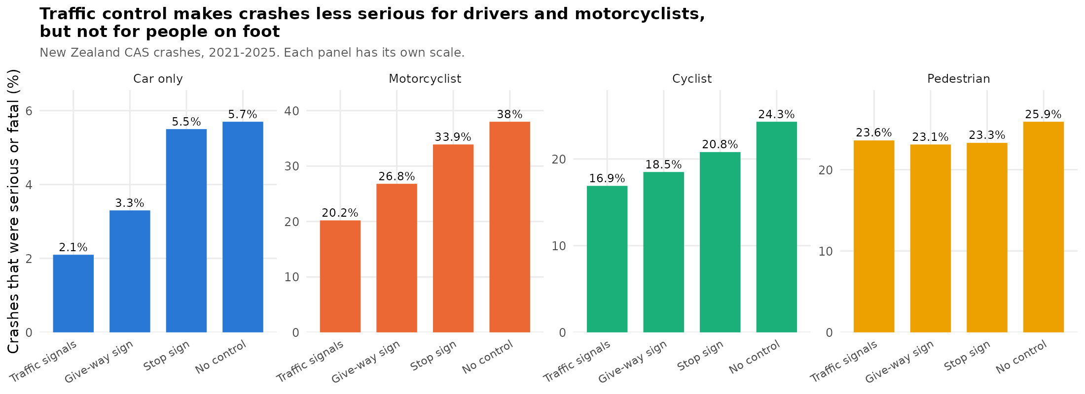
Figure 5. Severity by traffic control, shown separately for each road user. Note that each panel has its own vertical scale, because the underlying rates differ by a factor of ten.
For car-only crashes, severity rises steadily as control is removed: 2.1% at traffic signals, 3.3% at a give-way sign, 5.5% at a stop sign and 5.7% where there is no control at all. That is close to a threefold difference between the best and worst case. Motorcyclists follow the same shape at a much higher level, from 20.2% up to 38.0%. Cyclists show a smaller version of the same pattern, 16.9% to 24.3%.
Pedestrians do not follow it. Their four figures are 23.6%, 23.1%, 23.3% and 25.9% — essentially a flat line, and the signalised sites are not the safest of the four. Whatever control is present at the site makes almost no difference to how badly a pedestrian is hurt.

7.6 Speed affects everyone, but not equally
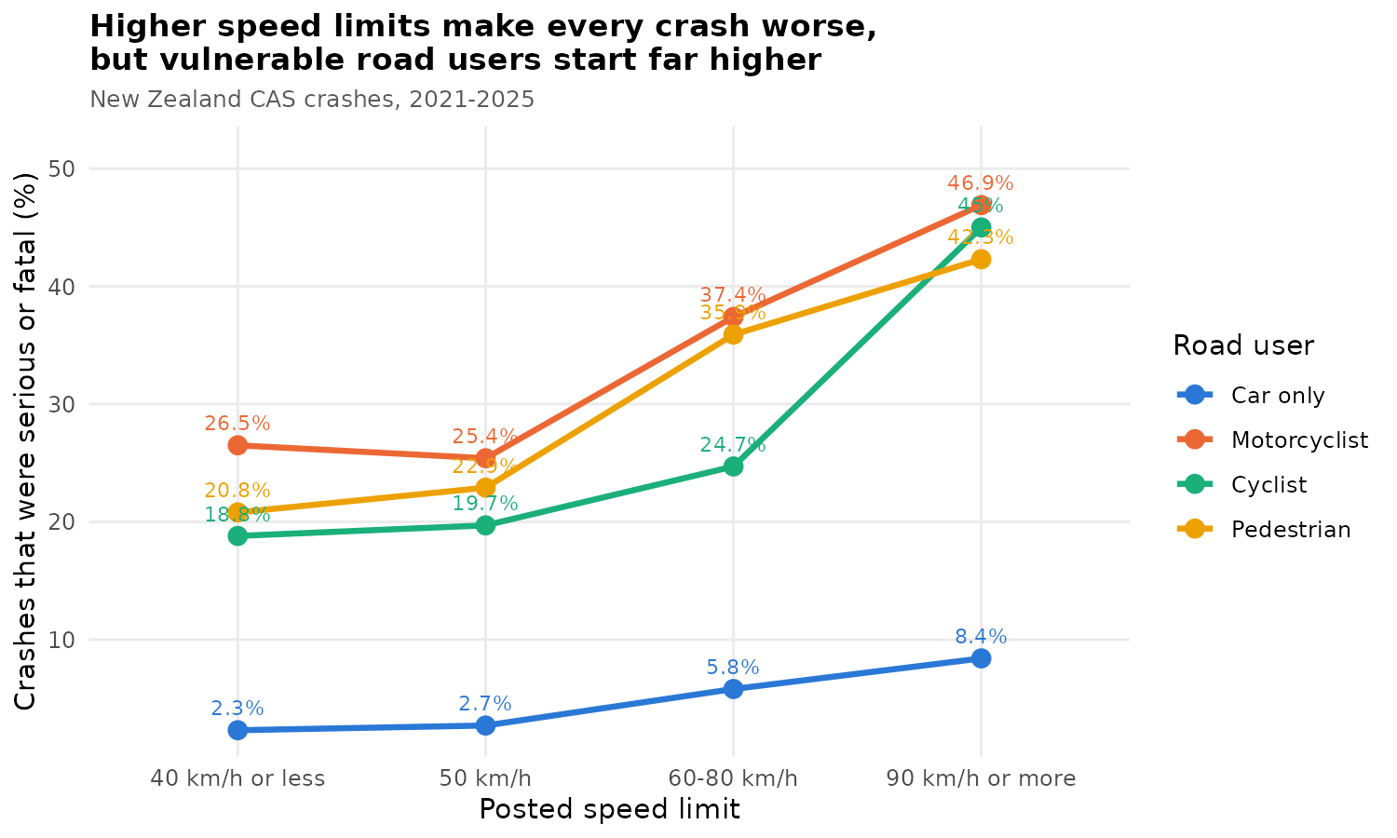
Figure 6. Severity by posted speed limit, for each road user.
Speed is the one factor that moves every group in the same direction. But the size of the move differs greatly. A car-only crash goes from about 2% serious at 50 km/h to about 8% above 90 km/h. A pedestrian crash goes from roughly 24% to over 40% across the same range. In absolute terms the speed penalty for a pedestrian is five times larger than for a car occupant. Speed is therefore the single lever that matters most for the people who are hurt worst, which is consistent with Chipperfield and Turner (2024).

8. Statistical testing
We tested each variable against the binary outcome with a chi-square test of independence. With 155,270 rows almost any association reaches significance, so we also calculated Cramér’s V, which measures how strong an association is on a scale from 0 to 1. Effect size is far more informative here than the p-value.
Variable | Chi-square | df | p-value | Cramér’s V
Road-user type | 12,984.8 | 3 | < 0.001 | 0.289
Speed limit band | 1,123.8 | 3 | < 0.001 | 0.085
Urban / open road | 820.9 | 1 | < 0.001 | 0.073
Traffic control | 370.6 | 3 | < 0.001 | 0.050
Road surface | 289.6 | 1 | < 0.001 | 0.043
Number of lanes | 232.8 | 2 | < 0.001 | 0.039
Weather | 177.9 | 1 | < 0.001 | 0.034
Flat or hill road | 156.3 | 1 | < 0.001 | 0.032
Road feature | 97.8 | 5 | < 0.001 | 0.025
State highway | 46.5 | 1 | < 0.001 | 0.017
Truck or bus involved | 29.2 | 1 | < 0.001 | 0.014
Light conditions | 8.2 | 2 | 0.017 | 0.007
Table 6. Chi-square tests against the serious-or-fatal outcome, 2021–2025, ordered by effect size.
Road-user type dominates at 0.289, roughly three and a half times the next strongest variable. Every feature of the road itself sits at 0.05 or below, which in conventional terms is a weak association. This is an important result on its own: what determines whether a crash is serious is mostly who was involved, not where it happened. It also tells us that a model built only from road features will not predict severity well.

9. Logistic regression
We split the modelling data 80% for training (113,661 crashes) and 20% for testing (28,415 crashes), using a fixed random seed of 123 so the results can be reproduced exactly. Two models were fitted on the training set.

9.1 Model 1: main effects
The first model includes all twelve variables as separate effects. Coefficients are shown as odds ratios: a value above 1 means the odds of a serious or fatal outcome go up, below 1 means they go down, with everything else held constant.
How to read an odds ratio. An odds ratio compares two situations that are otherwise the same. 1 means no difference, 2 means the odds of a serious outcome are doubled, and 0.5 means they are halved. Odds are not quite the same as chances. When an outcome is rare, as serious crashes are for cars, the two are close. When it is common, as for motorcyclists, the odds ratio makes the difference look bigger than the change in chances. That is why Section 9.3 and Section 1.1 turn the model into plain chances per 100 crashes.
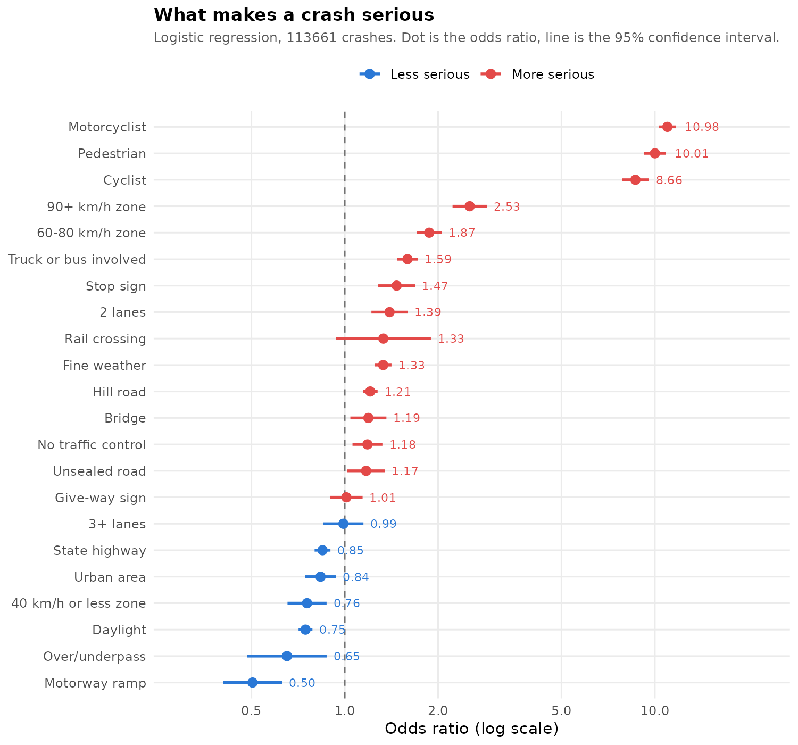
Figure 7. Adjusted odds ratios from Model 1. Dot is the estimate, line is the 95% confidence interval.
Variable | Odds ratio | 95% CI | p
Motorcyclist | 10.98 | 10.30 – 11.71 | < 0.001
Pedestrian | 10.01 | 9.23 – 10.86 | < 0.001
Cyclist | 8.66 | 7.84 – 9.57 | < 0.001
90 km/h or more zone | 2.53 | 2.23 – 2.87 | < 0.001
60–80 km/h zone | 1.87 | 1.71 – 2.06 | < 0.001
Truck or bus involved | 1.59 | 1.48 – 1.72 | < 0.001
Stop sign | 1.47 | 1.28 – 1.69 | < 0.001
2 lanes | 1.40 | 1.22 – 1.60 | < 0.001
Fine weather | 1.33 | 1.25 – 1.42 | < 0.001
Rail crossing | 1.33 | 0.94 – 1.90 | 0.111
Hill road | 1.21 | 1.14 – 1.28 | < 0.001
Bridge | 1.19 | 1.04 – 1.36 | 0.010
No traffic control | 1.18 | 1.06 – 1.32 | 0.003
Unsealed road | 1.17 | 1.02 – 1.35 | 0.026
Give-way sign | 1.01 | 0.90 – 1.14 | 0.846
3+ lanes | 0.99 | 0.85 – 1.15 | 0.897
State highway | 0.85 | 0.80 – 0.90 | < 0.001
Urban area | 0.84 | 0.75 – 0.94 | 0.002
40 km/h or less zone | 0.76 | 0.65 – 0.87 | < 0.001
Daylight | 0.75 | 0.71 – 0.79 | < 0.001
Over/underpass | 0.65 | 0.49 – 0.87 | 0.004
Motorway ramp | 0.50 | 0.41 – 0.63 | < 0.001
Table 7. Model 1 odds ratios. Reference groups: car-only crash, traffic signals, 50 km/h, open road, local road, sealed surface, one lane, standard road, dark, adverse weather, flat terrain.
Being a motorcyclist multiplies the odds of a serious outcome by about 11 compared with a car-only crash on the same kind of road. Pedestrians are at 10.0 and cyclists at 8.7. Nothing about the road itself comes close: the largest road effect is a 90 km/h-plus speed limit at 2.53.
Two results that look backwards. Fine weather has higher severity than adverse weather (1.33), and daylight has higher severity than darkness (0.75). Both are almost certainly behavioural: people drive more slowly and more carefully when conditions are poor. State highways also show lower severity than local roads once speed is controlled for (0.85), which reflects their higher engineering standard — wider lanes, better sight lines, fewer conflict points. These are useful reminders that a raw crash rate is not the same as risk.

9.2 Model 2: does traffic control work differently for different road users?
The second model adds two interaction terms: road-user type with traffic control, and road-user type with speed band. An interaction asks whether the effect of one variable depends on the value of another — exactly our main research question.
What an interaction means. An interaction asks whether the effect of one thing depends on another. Here the question is: does a site with no traffic control make crashes worse by the same amount for every road user? If it did, the interaction terms would all be close to 1. A value well below 1 for pedestrians means that the extra harm drivers suffer at uncontrolled sites mostly does not apply to pedestrians — because pedestrians are badly hurt at every kind of site.
Adding the interactions improves the model significantly (likelihood-ratio chi-square 49.21 on 18 degrees of freedom, p < 0.001) and lowers the AIC from 54,186.6 to 54,173.4. The improvement is driven almost entirely by the pedestrian terms:
Interaction term | Odds ratio | z | p
Pedestrian × stop sign | 0.46 | −3.73 | < 0.001
Pedestrian × no control | 0.67 | −2.83 | 0.005
Pedestrian × give-way sign | 0.80 | −1.44 | 0.150
Motorcyclist × no control | 1.07 | 0.45 | 0.655
Cyclist × no control | 1.01 | 0.05 | 0.960
Motorcyclist × stop sign | 1.01 | 0.03 | 0.977
Table 8. Selected interaction terms from Model 2. An odds ratio below 1 means the penalty that applies to other road users at that kind of site does not apply to pedestrians.
The reading is as follows. Removing traffic control raises severity for car occupants and motorcyclists, and the pedestrian interaction terms cancel most of that increase out. In other words, the penalty for being at an uncontrolled or stop-controlled site simply does not apply to people on foot. The motorcyclist and cyclist interactions are all close to 1 and not significant, meaning those groups behave like drivers, just at a higher baseline.

9.3 Predicted probabilities
Odds ratios are hard to read directly, so we used the model to predict the chance of a serious or fatal outcome for each combination, holding everything else at a typical urban setting.
Traffic control | Car only | Motorcyclist | Cyclist | Pedestrian
Traffic signals | 2.3% | 21.4% | 17.9% | 26.4%
Give-way sign | 2.5% | 22.9% | 19.9% | 23.1%
Stop sign | 3.9% | 31.5% | 21.4% | 21.9%
No control | 2.9% | 27.0% | 21.8% | 23.5%
Table 9. Predicted chance of a serious or fatal outcome from Model 2, with all other variables held at urban, 50 km/h, local sealed two-lane road, daylight, fine weather, no heavy vehicle.
The car-only column spans 2.3% to 3.9%, a 70% relative difference. The motorcyclist column spans 21.4% to 31.5%, a 47% relative difference. The pedestrian column runs 21.9% to 26.4% with no clear ordering, and signalised sites come out highest of the four.
Why this happens. Traffic control allocates right of way. That prevents vehicles colliding with each other, which is where most of the energy in a vehicle-to-vehicle crash comes from. It does not change what happens when a vehicle strikes a person who is walking. For a pedestrian the outcome is governed by the speed of the vehicle at impact and by the complete absence of anything between them and it. Right of way is irrelevant once contact occurs.

9.4 Checking the result without the “Unknown” years
Because almost all unknown traffic control is in 2021 and 2022 (Section 7.3), we fitted both models again on 2023–2025 only, where unknown is close to zero. This leaves 84,742 complete cases.
 | 2021–2025 (main model) | 2023–2025 only
Pedestrian × give-way sign | 0.80 (p = 0.150) | 0.65 (p = 0.016)
Pedestrian × stop sign | 0.46 (p < 0.001) | 0.45 (p < 0.001)
Pedestrian × no control | 0.67 (p = 0.005) | 0.56 (p < 0.001)
Likelihood-ratio test | χ² = 49.2, df 18, p < 0.001 | χ² = 35.6, df 18, p = 0.008
Pedestrian, signals vs no control | 26.4% vs 23.5% | 28.6% vs 23.2%
Car only, signals vs no control | 2.3% vs 2.9% | 2.2% vs 3.0%
Table 10. Pedestrian interaction odds ratios and predicted severity, main model compared with 2023–2025 only.
The finding is unchanged and, if anything, stronger. On the 2023–2025 data all three pedestrian terms are significant, including give-way, which was not significant before. The change in how traffic control was recorded does not explain the result.

10. Feature selection
We checked whether the model could be simplified. The drop1 test removes each variable in turn and measures how much worse the model becomes.
Variable removed | df | Deviance | LRT | p
Road-user type | 3 | 61,199 | 7,062.5 | < 0.001
Speed limit band | 3 | 54,365 | 228.3 | < 0.001
Light conditions | 2 | 54,259 | 122.8 | < 0.001
Number of lanes | 2 | 54,246 | 109.0 | < 0.001
Weather | 1 | 54,222 | 85.0 | < 0.001
Road feature | 5 | 54,200 | 63.7 | < 0.001
Traffic control | 3 | 54,195 | 58.7 | < 0.001
Flat or hill road | 1 | 54,182 | 45.2 | < 0.001
State highway | 1 | 54,167 | 30.5 | < 0.001
Urban / open road | 1 | 54,146 | 9.7 | 0.002
Road surface | 1 | 54,141 | 4.8 | 0.028
Table 11. drop1 results for Model 1. Full model deviance is 54,137.
Every variable makes a statistically significant contribution, and stepAIC run in both directions returned the full model unchanged. So nothing should be dropped. The scale of the differences is still informative: removing road-user type increases the deviance by 7,062, while removing traffic control increases it by 59. Both matter, but not by remotely the same amount.

11. Classification models
A problem that had to be solved first. Only 7.6% of crashes are serious or fatal. If a classifier is judged at the usual 0.5 probability cut-off, it can label every single crash “minor”, be right 92% of the time, and identify nothing at all. We handled this in two ways: for the regression and the decision tree we set the cut-off at the training event rate (0.079) instead of 0.5, and for the random forest we drew an equal number of serious and minor crashes into every tree. Without that second step the forest’s AUC falls from 0.745 to 0.595. This is why we report AUC and sensitivity rather than accuracy alone.

11.1 Decision tree
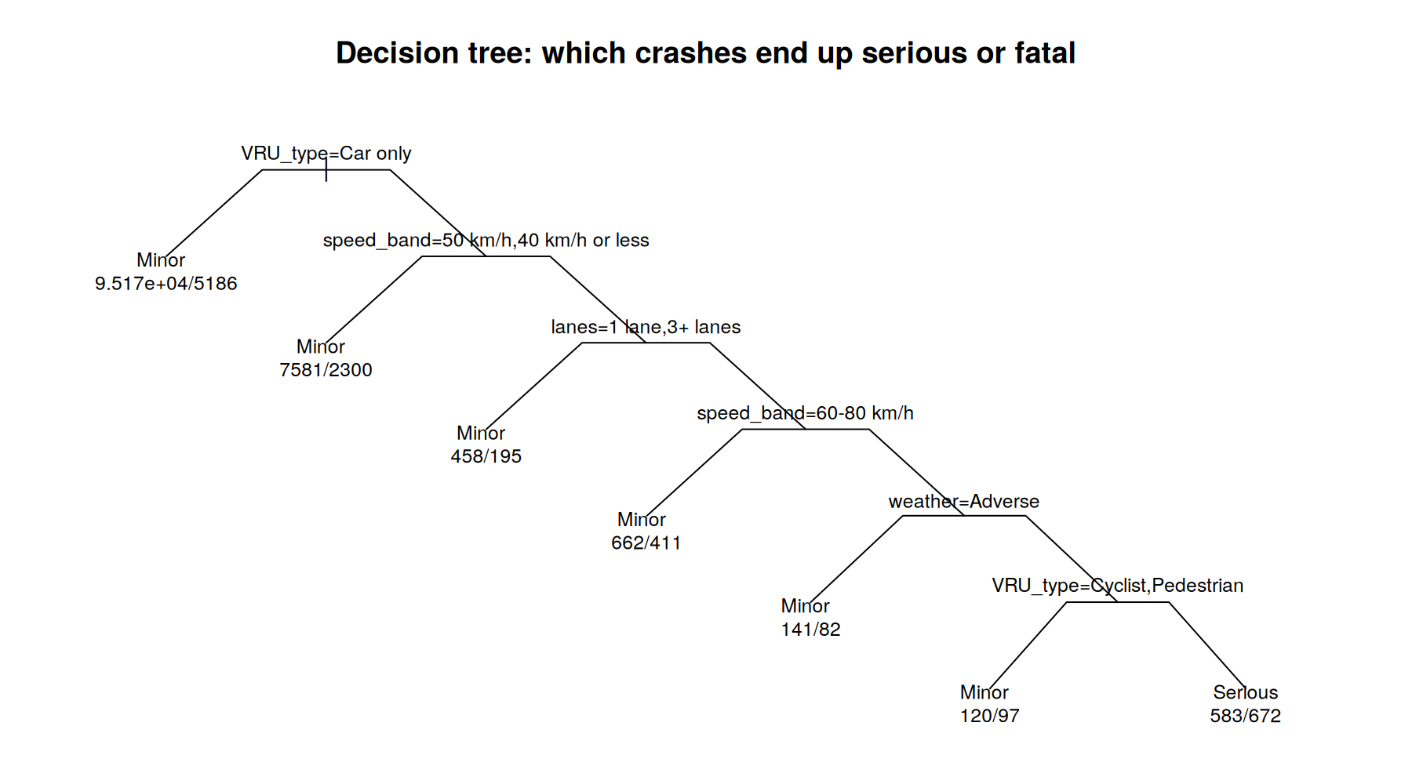
Figure 8. The pruned classification tree, cut back to seven leaves using cross-validation.
The tree splits first on whether a vulnerable road user was involved, which confirms the chi-square and regression results from a completely different method. It then splits on speed band, lanes, speed band again, and weather. The only leaf it labels “serious” is cyclists and pedestrians in 60 km/h-plus zones in fine weather, which is a very narrow rule and explains the tree’s weak overall discrimination.

11.2 Random forest
The forest was grown with 300 trees, a minimum node size of 50, and balanced sampling. Its out-of-bag error rate is 29.2%. Variable importance confirms the same ordering yet again:
Variable | Mean decrease in Gini | Rank
Road-user type | 1,323.8 | 1
Speed limit band | 176.1 | 2
Urban / open road | 126.0 | 3
Number of lanes | 94.7 | 4
Traffic control | 74.8 | 5
Light conditions | 43.5 | 6
Weather | 38.1 | 7
Truck or bus involved | 29.9 | 8
Flat or hill road | 26.0 | 9
State highway | 25.7 | 10
Road surface | 15.1 | 11
Table 12. Random forest variable importance. Road-user type is more than seven times more important than the next variable.

11.3 Comparing the three models
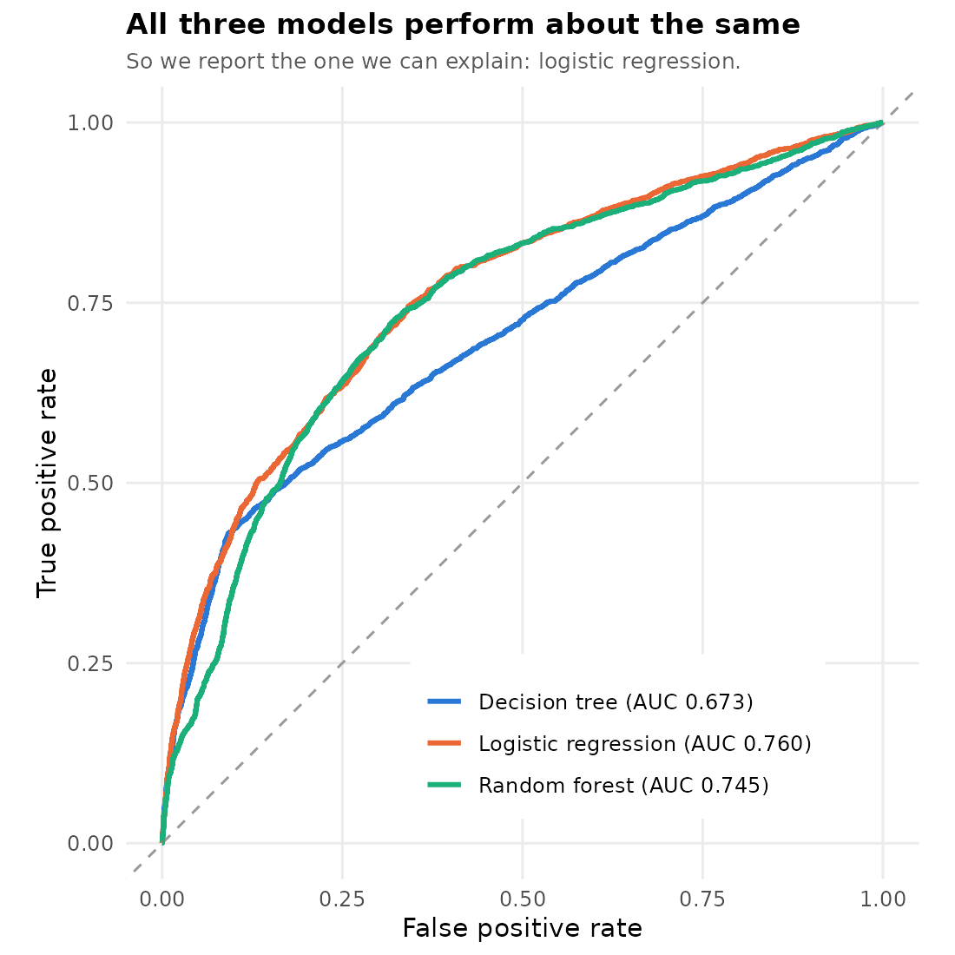
Figure 9. ROC curves on the 28,415 test crashes.
Model | AUC | Accuracy | Sensitivity | Comment
Logistic regression | 0.760 | 0.733 | 0.646 | Best AUC, and the coefficients can be read directly
Random forest | 0.745 | 0.712 | 0.682 | No better, and much harder to explain
Decision tree | 0.673 | 0.871 | 0.429 | High accuracy only because it says “minor” most of the time
Table 13. Model comparison.
The decision tree illustrates the imbalance trap perfectly: it has by far the highest accuracy and by far the worst AUC. Accuracy alone would have led us to the worst model.
Confusion matrix for the logistic model at the 0.079 cut-off: of 2,236 genuinely serious crashes in the test set it correctly flags 1,444, and of 26,179 minor crashes it correctly clears 19,376. That is 65% sensitivity at 74% specificity. This is useful for ranking risk across locations or road types, but it is nowhere near accurate enough to predict any individual crash, and we do not claim that it is.
Since the simplest model performs at least as well as the other two, we report the logistic regression. All three agree on which factors matter, which is itself a form of validation.

12. Discussion
Three results come together into one argument.
First, who is involved in a crash matters far more than where it happened. Road-user type has a Cramér’s V of 0.289 against 0.05 or less for every road feature, an odds ratio near 11 against 2.5 for the strongest road variable, and it is the first split in the decision tree and the top variable in the random forest. Four different methods agree.
Second, the protection the road provides is not distributed evenly. Traffic control produces a clear severity gradient for drivers and motorcyclists and essentially none for pedestrians. The interaction is statistically significant, it holds after adjusting for eleven other variables, it holds in every five-year period for twenty years, and it holds when non-injury crashes are excluded. This is consistent with the mechanism: control manages right of way between vehicles, and right of way stops mattering the moment a vehicle contacts a person on foot.
Third, the harm is geographically diffuse. Site-based programmes therefore cannot reach most of it even if the treatments worked equally well for everyone, which they do not.
The year-by-year figures in Section 7 point the same way. Total reported crashes fell by 15% in five years, yet serious and fatal crashes did not fall, and crashes involving vulnerable road users held steady while everything else declined. Whatever is reducing crash numbers is mostly reducing the least serious crashes between vehicles.
Taken together these say that the standard response to a dangerous location — add control — is well matched to vehicle-to-vehicle crashes and poorly matched to the crashes that now produce the most serious harm per crash. The twenty-year trend suggests this mismatch has been widening rather than closing, even as overall road safety has improved.
Our finding does not contradict Tanishita et al. (2023), who reported that signals reduce pedestrian fatality risk in Japan. Their study compares signalised with unsignalised sites for pedestrians only, in a different road system and with a different speed environment. The point we add is the comparison between road users within the same data: whatever benefit exists for pedestrians is much smaller than the benefit the same treatment gives drivers, and in New Zealand it has been shrinking.

12.1 What missing exposure data does and does not affect
Exposure means how much travel is happening: how many people walk, cycle or drive past a place, or how far and how long they travel. CAS records crashes, not exposure. This matters for some of our questions and not for others.
What exposure does not affect: the main finding. Our main result compares the share of crashes that are serious. If twice as many pedestrians cross at a site, we would expect about twice as many pedestrian crashes there — but no reason for each of those crashes to be any more or less serious. Exposure changes how many crashes happen, not how bad each one is. So the finding that traffic control does not reduce how badly a pedestrian is hurt once struck stands without exposure data.
What exposure does affect: whether signals prevent pedestrian crashes. We cannot tell from CAS whether signals reduce the chance of a pedestrian being hit in the first place. They may well do. Our claim is narrower: signals do not make the pedestrian crashes that do happen any less severe. That is why we recommend signals for conflicts between vehicles, but not as a measure to reduce how badly pedestrians are hurt.
We made two checks to see how far exposure could change the picture.
Check 1 — national exposure by travel mode. The Ministry of Transport publishes deaths and injuries per hour and per kilometre travelled, using the New Zealand Household Travel Survey:
Travel mode | Per million hours | Per 100 million km | Compared with drivers (per hour)
Motorcyclist | 196 | 458 | about 25 times
Cyclist | 31 | 248 | about 4 times
Car or van driver | 8 | 22 | —
Pedestrian | 4.6 | 116 | about 0.6 times
Table 19. Deaths and injuries by travel mode, 2010–2014. Source: Ministry of Transport (2015). All injury levels included.
These figures do include exposure. They confirm that motorcyclists are by far the highest-risk group, about 25 times drivers for every hour travelled, which matches our finding that motorcyclists have the highest severity and the fastest-rising crash numbers. Pedestrians look safer per hour, mainly because walking is slow and much of it happens away from traffic, but they are about five times riskier than drivers per kilometre. The figures are older and national, so we use them as context and not in our models.
Check 2 — how often each group is involved at each kind of site. As a rough stand-in for how busy each kind of site is, we used the number of car-only crashes there. We then counted crashes involving each vulnerable road user for every 1,000 car-only crashes.
Traffic control | Motorcyclist | Cyclist | Pedestrian
Traffic signals | 43.8 | 29.9 | 57.6
Give-way sign | 73.3 | 59.9 | 44.5
Stop sign | 70.9 | 38.3 | 39.5
No control | 55.8 | 18.2 | 44.8
Table 20. Crashes involving each vulnerable road user for every 1,000 car-only crashes at the same kind of site, 2021–2025.
Pedestrians are involved in roughly a third more crashes at signals than at uncontrolled or give-way sites, relative to vehicle activity (57.6 against about 45 per 1,000). That is what we would expect if more people walk through signalised intersections, and it supports the idea that exposure differs between kinds of site. It cannot tell us whether this reflects more walking or more risk. Either way it does not change the severity result, because severity is measured within each group of crashes. Motorcyclists and cyclists show the opposite pattern: they are least often involved at signals and most often at give-way sites, which is useful for deciding where to look first.
What would close the gap. Pedestrian and cycle counts at a sample of signalised and uncontrolled sites would turn this into a true risk analysis. That is recommendation 6.

13. Recommendations
The table below is a quick guide for planners. It starts from the problem at a site and gives the response our evidence supports. The numbered recommendations that follow explain each one.
Problem at a site | What the data shows | Response our evidence supports | See
Crashes between vehicles at an intersection | Signals cut serious car-only crashes from about 6 to 2 per 100 | Signals or stronger traffic control | 7.5, 1.1
Serious injuries to pedestrians | Control makes almost no difference (24 vs 26 per 100); speed does (about 24 at 50 km/h, over 40 at 90 km/h and above) | Lower speed limits, raised crossings, physical separation | 7.6, 9.3
Motorcycle crashes | Highest severity (about 34 per 100) and rising; signals roughly halve severity | Site control plus rider-focused measures | 7.4, 12.1
Cyclist crashes | Signals help moderately (17 vs 24 per 100); cyclists most often involved at give-way sites | Separated cycle paths; review give-way sites on cycle routes | 7.5, 14.1
Harm spread across many locations | The worst 100 one-kilometre squares hold only 15% of serious VRU crashes | Area-wide measures, not only black-spot fixes | 13
Judging whether a programme worked | Total crashes fell 15% in five years; serious and fatal crashes did not | Track serious and fatal crashes, not totals | 7.1
Table 21. Decision guide for planners. Numbers in the last column are report sections.
- Treat signalisation as a measure that protects drivers, not pedestrians. It is worth doing where vehicle-to-vehicle conflict is the problem, and our data supports that use. It should not be counted as a pedestrian safety project or used to justify one.
- Use speed to protect pedestrians. Speed is the only variable in our model that moves pedestrian severity substantially, from about 24% serious at 50 km/h to over 40% above 90 km/h. Speed limits act across whole areas at once, which suits a problem spread over three thousand locations.
- Prefer physical separation where people walk and cycle. Grade separation shows the largest protective effects anywhere in our model: motorway ramps at 0.50 and over or underpasses at 0.65. Separating people from vehicles works; managing who goes first does not.
- Give motorcyclists specific attention. They have the highest severity rate of any group at 33.8%, the highest fatal rate at 3.12%, and the only large increase in absolute serious crashes over twenty years at 17%. Unlike pedestrians they do respond strongly to traffic control, so site-based work is worthwhile for them.
- Do not rely on black-spot programmes alone for vulnerable road users. The worst hundred one-kilometre squares contain 15.3% of serious crashes involving them. Area-wide measures are required to reach the rest.
- Collect exposure data. The largest gap in this analysis, and in most crash analysis, is that we know how many crashes happened but not how many people walked, cycled or drove past. Pedestrian and cycle counts at a sample of sites would let future work estimate risk rather than severity.
- Measure progress with serious and fatal crashes, not total crashes. Between 2021 and 2025 total crashes fell 15% while serious and fatal crashes did not change. A target based on total crashes would have reported success that did not happen.

14. Limitations and assumptions

14.1 Limitations
- We measure how serious a crash was, not how likely a crash is, because CAS contains no exposure data. Section 14.1 explains why this does not affect our main finding, which compares severity within groups of crashes, and adds two checks using national travel data and a site-level proxy. It does leave open whether signals reduce the number of pedestrian crashes, which this data cannot test.
- CAS records only crashes reported to police. Under-reporting of crash victims in New Zealand is documented (Alsop and Langley, 2001) and is known to be worst for minor pedestrian and cyclist crashes. Their severity rates in our tables are therefore higher than the true rates. The main finding is not damaged by this, because the under-reporting should be broadly similar at every type of traffic control, so it affects the level rather than the comparison.
- The recording of serious injuries has changed over twenty years. For this reason our long-run argument rests on the gap between road users within a period, not on comparing severity levels across periods.
- The way traffic control is recorded changed during the study period: unknown fell from 2,489 crashes in 2021 to fewer than 50 a year from 2023. The main result holds on 2023–2025 alone (Section 9.4), but year-to-year comparisons of traffic-control counts before 2023 should be read with care.
- Crash severity in CAS is the severity of the worst injury in the crash, not of a specific person. In a crash between a car and a pedestrian, the serious injury is almost always the pedestrian, but this is an assumption rather than a recorded fact.
- The models are associations, not causal estimates. We cannot say that changing the traffic control at a site would produce the change in severity our model predicts.

14.2 Modelling assumptions
- A blank road-user column means nobody of that type was involved. We verified this pattern is identical in every five-year period.
- Complete-case analysis drops 8.5% of crashes. We assume those are missing for reasons unrelated to severity.
- Each crash is labelled by the most vulnerable person involved, so information about other people in the same crash is not used except through the heavy-vehicle variable.
- Binary severity treats a fatal crash and a serious crash as the same outcome. We report fatal rates separately in Table 5 to show what this hides.
- Speed limit is the posted limit, not the speed of travel. Actual impact speed is not recorded in CAS.
- Crashes are treated as independent observations. In reality crashes at the same location may be correlated, which could make our confidence intervals slightly too narrow.

15. Conclusion and future work
New Zealand’s road environment protects people in vehicles considerably better than it protects people outside them, and the difference is largest for the one intervention that is most often used. Traffic control produces a clear severity benefit for drivers and motorcyclists and almost none for pedestrians. This is not a recent development: it is present in every five-year period since 2006, it is statistically significant throughout, it survives a control for changes in crash reporting, and it has widened over the twenty years. Over the same period serious crashes fell for car occupants and cyclists and rose for motorcyclists and pedestrians.
Because serious harm to vulnerable road users is spread across more than three thousand locations, and because the usual site treatment does little for the group most at risk, the tools that can actually reduce this harm are area-wide: lower speeds and physical separation.

15.1 Future work
- Add exposure data. Pedestrian and cycle counts would turn severity analysis into risk analysis and would resolve the study’s main limitation.
- Model severity as an ordered outcome across all four CAS levels rather than a binary split, which would use information the current model discards.
- Add vehicle characteristics. Vehicle mass and front-end geometry are known to matter for pedestrian outcomes and are not in our model.
- Account for location clustering with a mixed-effects or multi-level model, which would give more honest confidence intervals.
- Evaluate specific treatments directly by comparing severity before and after signalisation at the same sites, which would move the analysis closer to a causal claim.

16. References
Alsop, J., & Langley, J. (2001). Under-reporting of motor vehicle traffic crash victims in New Zealand. Accident Analysis & Prevention.
Chipperfield, J., & Turner, S. (2024, April). The influence of speed limits on casualty outcomes. Abley. https://abley.com/our-insights/speed-limits-casualty-outcomes
Komol, M. M. R., Hasan, M. M., Elhenawy, M., Yasmin, S., Masoud, M., & Rakotonirainy, A. (2021). Crash severity analysis of vulnerable road users using machine learning. PLOS ONE, 16(8), e0255828.
Ministry of Transport. (2015). Risk on the road: Introduction and mode comparison. Ministry of Transport, Wellington. https://www.transport.govt.nz/assets/Uploads/Report/Risk-2015-intro-overview-final.pdf
NZ Transport Agency Waka Kotahi. (2026). Crash Analysis System (CAS) data [Open dataset]. https://opendata-nzta.opendata.arcgis.com
NZ Transport Agency Waka Kotahi. Crash estimation compendium: New Zealand crash risk factors guideline. https://www.nzta.govt.nz
Tanishita, M., Sekiguchi, Y., & Sunaga, D. (2023). Impact analysis of road infrastructure and traffic control on severity of pedestrian–vehicle crashes at intersections and non-intersections using bias-reduced logistic regression. IATSS Research, 47(2), 233–239.

Appendix A — Tableau dashboard
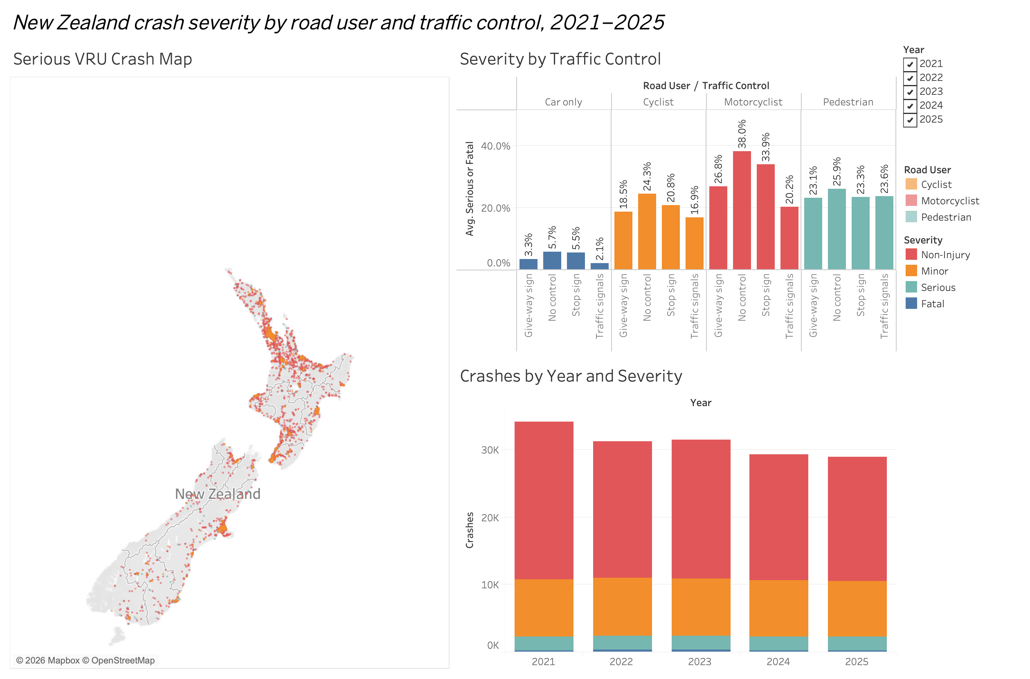
Figure 12. Interactive dashboard built in Tableau Desktop from the same 2021–2025 data: the serious VRU crash map, severity by traffic control, and crashes by year. The workbook (INFO634_Group21_Tableau.twbx) is included in the submission.

Appendix B — Full R code
The complete analysis script. It runs from start to finish and produces every number, table and figure in this report. The random seed is fixed at 123 throughout so results reproduce exactly.
####################################################################
# INFO634 26S2 - Group 21 Project
# Vehicle crashes in New Zealand:
# who the road environment protects, and who it leaves behind
#
# Part 1: 2021-2025 main models
# Part 2: 2021-2025 year-by-year view and a data-quality check
# Part 3: 2021-2025 plain-language view and an exposure check
#
# Run this file from the folder that holds the CSV file.
####################################################################

library(ggplot2)
library(caTools)
library(MASS)
library(rpart)
library(randomForest)

PART1FILE <- "CAS_2021_2025_part1.csv"
FIGDIR <- "figures"
if (!dir.exists(FIGDIR)) dir.create(FIGDIR)

# shared colours so every figure matches
user_cols <- c("Car only" = "#2a78d6", "Motorcyclist" = "#eb6834",
"Cyclist" = "#1baf7a", "Pedestrian" = "#eda100")

# a small helper: label each crash by the most vulnerable person involved
label_user <- function(d) {
for (v in c("bicycle", "motorcycle", "moped", "pedestrian")) {
x <- suppressWarnings(as.numeric(d[[v]])); x[is.na(x)] <- 0; d[[v]] <- x
}
d$VRU_type <- "Car only"
d$VRU_type[d$motorcycle > 0 | d$moped > 0] <- "Motorcyclist"
d$VRU_type[d$bicycle > 0] <- "Cyclist"
d$VRU_type[d$pedestrian > 0] <- "Pedestrian"
d$VRU_type <- factor(d$VRU_type,
levels = c("Car only", "Motorcyclist", "Cyclist", "Pedestrian"))
d
}

tidy_control <- function(x) {
y <- rep(NA_character_, length(x))
y[x == "Traffic Signals"] <- "Traffic signals"
y[x == "Give way"] <- "Give-way sign"
y[x == "Stop"] <- "Stop sign"
y[x == "Nil"] <- "No control"
factor(y, levels = c("Traffic signals", "Give-way sign", "Stop sign", "No control"))
}

####################################################################
# PART 1 - the current picture, 2021 to 2025
####################################################################

## ---- 1. read and pre-process -------------------------------------
crash <- read.csv(PART1FILE, stringsAsFactors = FALSE)
cat("crashes 2021-2025:", nrow(crash), "\n")

crash <- label_user(crash)

for (v in c("truck", "bus")) {
x <- suppressWarnings(as.numeric(crash[[v]])); x[is.na(x)] <- 0; crash[[v]] <- x
}
crash$heavy_vehicle <- ifelse(crash$truck > 0 | crash$bus > 0, 1, 0)

crash$serious_fatal <- ifelse(crash$crashSeverity %in% c("Serious Crash", "Fatal Crash"), 1, 0)
crash$fatal <- ifelse(crash$crashSeverity == "Fatal Crash", 1, 0)

crash$traffic_control <- tidy_control(crash$trafficControl)

crash$state_highway <- factor(ifelse(crash$crashSHDescription == "Yes", "State highway",
ifelse(crash$crashSHDescription == "No", "Local road", NA)))

crash$road_surface <- NA
crash$road_surface[crash$roadSurface == "Sealed"] <- "Sealed"
crash$road_surface[crash$roadSurface %in% c("Unsealed", "End of seal")] <- "Unsealed"
crash$road_surface <- factor(crash$road_surface)

rc <- crash$roadCharacter
crash$road_character <- ifelse(rc == "Nil", "Standard road",
ifelse(rc == "Bridge", "Bridge",
ifelse(rc == "Motorway ramp", "Motorway ramp",
ifelse(rc %in% c("Overpass", "Underpass", "Tunnel"), "Over/underpass",
ifelse(rc == "Rail xing", "Rail crossing", "Other feature")))))
crash$road_character <- relevel(factor(crash$road_character), ref = "Standard road")

crash$NumberOfLanes[crash$NumberOfLanes == 0] <- NA
crash$lanes <- cut(crash$NumberOfLanes, breaks = c(0, 1, 2, 20),
labels = c("1 lane", "2 lanes", "3+ lanes"))

crash$speedLimit[crash$speedLimit < 10 | crash$speedLimit > 110] <- NA
crash$speed_band <- cut(crash$speedLimit, breaks = c(0, 40, 50, 80, 120),
labels = c("40 km/h or less", "50 km/h", "60-80 km/h", "90 km/h or more"))
crash$speed_band <- relevel(crash$speed_band, ref = "50 km/h")

crash$area <- factor(ifelse(crash$urban == "Urban", "Urban",
ifelse(crash$urban == "Open", "Open road", NA)))

crash$light_cond <- NA
crash$light_cond[crash$light %in% c("Bright sun", "Overcast")] <- "Daylight"
crash$light_cond[crash$light == "Twilight"] <- "Twilight"
crash$light_cond[crash$light == "Dark"] <- "Dark"
crash$light_cond <- factor(crash$light_cond)

crash$weather <- NA
crash$weather[crash$weatherA == "Fine"] <- "Fine"
crash$weather[crash$weatherA %in% c("Light rain", "Heavy rain", "Mist or Fog",
"Snow", "Hail or Sleet")] <- "Adverse"
crash$weather <- factor(crash$weather)

crash$terrain <- factor(ifelse(crash$flatHill %in% c("Flat", "Hill Road"), crash$flatHill, NA))

mv <- c("serious_fatal", "VRU_type", "traffic_control", "speed_band", "area",
"state_highway", "road_surface", "lanes", "road_character",
"light_cond", "weather", "terrain", "heavy_vehicle")
model_data <- na.omit(crash[, mv])
cat("complete cases for modelling:", nrow(model_data), "\n")
cat("serious or fatal:", round(100 * mean(crash$serious_fatal), 2), "%\n")

## ---- 2. descriptive tables ---------------------------------------
tab_user <- aggregate(cbind(serious_fatal, fatal) ~ VRU_type, data = crash, FUN = mean)
tab_user$n <- as.numeric(table(crash$VRU_type))
tab_user$pct_SF <- round(100 * tab_user$serious_fatal, 1)
tab_user$pct_F <- round(100 * tab_user$fatal, 2)
print(tab_user[, c("VRU_type", "n", "pct_SF", "pct_F")])

tab_core <- aggregate(serious_fatal ~ traffic_control + VRU_type, data = crash, FUN = mean)
tab_core$pct <- round(100 * tab_core$serious_fatal, 1)
tab_core$n <- aggregate(serious_fatal ~ traffic_control + VRU_type,
data = crash, FUN = length)$serious_fatal
print(tab_core)

## ---- 3. chi-square with effect size ------------------------------
# Cramer's V shows how strong an association is. With 150,000 rows
# nearly everything is "significant", so size matters more than p.
cramers_v <- function(tbl) {
cs <- suppressWarnings(chisq.test(tbl))
as.numeric(sqrt(cs$statistic / (sum(tbl) * (min(dim(tbl)) - 1))))
}
chi_vars <- c("VRU_type", "traffic_control", "state_highway", "road_character",
"road_surface", "lanes", "speed_band", "area", "light_cond",
"weather", "terrain", "heavy_vehicle")
chi_out <- data.frame()
for (v in chi_vars) {
tbl <- table(crash[[v]], crash$serious_fatal)
cs <- suppressWarnings(chisq.test(tbl))
chi_out <- rbind(chi_out, data.frame(
variable = v, chi_sq = round(as.numeric(cs$statistic), 1),
df = as.numeric(cs$parameter), p_value = cs$p.value,
cramers_v = round(cramers_v(tbl), 4)))
}
chi_out <- chi_out[order(-chi_out$cramers_v), ]
print(chi_out, row.names = FALSE)

## ---- 4. train / test split ---------------------------------------
set.seed(123)
split <- sample.split(model_data$serious_fatal, SplitRatio = 0.8)
train <- model_data[split == TRUE, ]
test <- model_data[split == FALSE, ]
cat("train:", nrow(train), " test:", nrow(test), "\n")

## ---- 5. logistic regression --------------------------------------
lmodel1 <- glm(serious_fatal ~ VRU_type + traffic_control + speed_band + area +
state_highway + road_surface + lanes + road_character +
light_cond + weather + terrain + heavy_vehicle,
data = train, family = binomial)
summary(lmodel1)

# Model 2 adds the combinations we care about. VRU_type * traffic_control
# asks whether traffic control works differently for different road users.
lmodel2 <- glm(serious_fatal ~ VRU_type * traffic_control + VRU_type * speed_band +
area + state_highway + road_surface + lanes + road_character +
light_cond + weather + terrain + heavy_vehicle,
data = train, family = binomial)
summary(lmodel2)

lr <- anova(lmodel1, lmodel2, test = "Chisq")
print(lr)

odds <- data.frame(OR = exp(coef(lmodel1)), exp(confint.default(lmodel1)))
colnames(odds) <- c("OR", "CI_low", "CI_high")
odds$p <- summary(lmodel1)$coefficients[, 4]
print(round(odds, 3))

## ---- 6. confusion matrix -----------------------------------------
res <- predict(lmodel2, test, type = "response")

# Only about 8% of crashes are serious. At the usual 0.5 cut-off the
# model would call every crash minor. We use the training rate instead.
cutoff <- mean(train$serious_fatal)
cat("cut-off:", round(cutoff, 3), "\n")

t1 <- table(ActVal = test$serious_fatal, PreVal = res > cutoff)
print(t1)
cat("accuracy :", round((t1[1,1] + t1[2,2]) / sum(t1), 3), "\n")
cat("sensitivity:", round(t1[2,2] / sum(t1[2, ]), 3), "\n")
cat("specificity:", round(t1[1,1] / sum(t1[1, ]), 3), "\n")
auc_glm <- as.numeric(colAUC(res, test$serious_fatal))
cat("AUC :", round(auc_glm, 4), "\n")

## ---- 7. adjusted predictions -------------------------------------
grid <- expand.grid(
VRU_type = levels(model_data$VRU_type),
traffic_control = levels(model_data$traffic_control),
speed_band = "50 km/h", area = "Urban", state_highway = "Local road",
road_surface = "Sealed", lanes = "2 lanes", road_character = "Standard road",
light_cond = "Daylight", weather = "Fine", terrain = "Flat", heavy_vehicle = 0)
grid$pred_pct <- round(100 * predict(lmodel2, grid, type = "response"), 1)
adjusted <- reshape(grid[, c("traffic_control", "VRU_type", "pred_pct")],
idvar = "traffic_control", timevar = "VRU_type", direction = "wide")
print(adjusted, row.names = FALSE)

## ---- 8. feature selection ----------------------------------------
print(drop1(lmodel1, test = "Chisq"))
lmodel_aic <- stepAIC(lmodel1, direction = "both", trace = FALSE)
print(formula(lmodel_aic))
print(AIC(lmodel1, lmodel2, lmodel_aic))

## ---- 9. decision tree --------------------------------------------
train$sf_factor <- factor(train$serious_fatal, labels = c("Minor", "Serious"))
test$sf_factor <- factor(test$serious_fatal, labels = c("Minor", "Serious"))

set.seed(123)
mytree <- rpart(sf_factor ~ VRU_type + traffic_control + speed_band + area +
state_highway + road_surface + lanes + light_cond +
weather + terrain + heavy_vehicle,
data = train, method = "class",
control = rpart.control(cp = 0.0005, minbucket = 50))

# prune back to the size with the lowest cross-validation error
best_cp <- mytree$cptable[which.min(mytree$cptable[, "xerror"]), "CP"]
prune_tree <- prune(mytree, cp = best_cp)
cat("leaves after pruning:", sum(prune_tree$frame$var == "<leaf>"), "\n")

tree_prob <- predict(prune_tree, test)[, "Serious"]
t2 <- table(ActVal = test$sf_factor, PreVal = tree_prob > cutoff)
print(t2)
auc_tree <- as.numeric(colAUC(tree_prob, test$serious_fatal))
cat("tree accuracy:", round(sum(diag(t2)) / sum(t2), 3), " AUC:", round(auc_tree, 4), "\n")

options(scipen = 999)
png(file.path(FIGDIR, "fig5_tree.png"), width = 1800, height = 1000, res = 190)
par(mar = c(1, 1, 3.5, 1), xpd = NA)
plot(prune_tree, uniform = TRUE, compress = TRUE, branch = 0.4, margin = 0.08,
main = "Decision tree: which crashes end up serious or fatal")
text(prune_tree, use.n = TRUE, all = FALSE, cex = 0.78, pretty = 0, font = 1)
dev.off()

## ---- 10. random forest -------------------------------------------
# Serious crashes are rare, so we draw an equal number of serious and
# minor crashes into every tree. Without this the forest finds nothing.
n_pos <- sum(train$sf_factor == "Serious")
set.seed(123)
rf <- randomForest(sf_factor ~ VRU_type + traffic_control + speed_band + area +
state_highway + road_surface + lanes + light_cond +
weather + terrain + heavy_vehicle,
data = train, ntree = 300, nodesize = 50,
strata = train$sf_factor,
sampsize = c(Minor = n_pos, Serious = n_pos))
print(rf)
imp <- data.frame(variable = rownames(importance(rf)),
gini = as.numeric(importance(rf)))
imp <- imp[order(-imp$gini), ]
print(imp, row.names = FALSE)

rf_prob <- predict(rf, test, type = "prob")[, "Serious"]
t3 <- table(ActVal = test$sf_factor, PreVal = rf_prob > 0.5)
print(t3)
auc_rf <- as.numeric(colAUC(rf_prob, test$serious_fatal))
cat("forest accuracy:", round(sum(diag(t3)) / sum(t3), 3), " AUC:", round(auc_rf, 4), "\n")

cat("\n--- model comparison ---\n")
cat("logistic regression AUC:", round(auc_glm, 4), "\n")
cat("decision tree AUC:", round(auc_tree, 4), "\n")
cat("random forest AUC:", round(auc_rf, 4), "\n")

## ---- 11. how concentrated is the harm? ---------------------------
vru <- crash[crash$VRU_type != "Car only" & crash$serious_fatal == 1, ]
vru <- vru[!is.na(vru$X) & !is.na(vru$Y) & vru$X > 1050000 & vru$X < 2100000 &
vru$Y > 4700000 & vru$Y < 6250000, ]
vru$cell <- paste(floor(vru$X / 1000), floor(vru$Y / 1000))
cells <- sort(table(vru$cell), decreasing = TRUE)
cat("serious VRU crashes:", nrow(vru), " in", length(cells), "one-km squares\n")
for (n in c(10, 50, 100, 250, 500)) {
cat(" worst", n, "squares hold",
round(100 * sum(head(cells, n)) / sum(cells), 1), "%\n")
}

####################################################################
# FIGURES
####################################################################
base_theme <- theme_minimal(base_size = 11) +
theme(plot.title = element_text(face = "bold", size = 12),
plot.subtitle = element_text(colour = "grey35", size = 9),
panel.grid.minor = element_blank())

## Figure 1 - the multivariate graphic
p1 <- tab_core[!is.na(tab_core$traffic_control), ]
fig1 <- ggplot(p1, aes(x = traffic_control, y = pct, fill = VRU_type)) +
geom_col(width = 0.72) +
geom_text(aes(label = paste0(pct, "%")), vjust = -0.45, size = 3) +
facet_wrap(~ VRU_type, scales = "free_y", nrow = 1) +
scale_fill_manual(values = user_cols) +
scale_y_continuous(expand = expansion(mult = c(0, 0.15))) +
labs(title = "Traffic control makes crashes less serious for drivers and motorcyclists,\nbut not for people on foot",
subtitle = "New Zealand CAS crashes, 2021-2025. Each panel has its own scale.",
x = NULL, y = "Crashes that were serious or fatal (%)") +
base_theme + theme(legend.position = "none",
axis.text.x = element_text(angle = 30, hjust = 1, size = 8))
ggsave(file.path(FIGDIR, "fig1_control_by_user.png"), fig1, width = 11, height = 4, dpi = 200)

## Figure 2 - speed limit
spd <- aggregate(serious_fatal ~ speed_band + VRU_type, data = crash, FUN = mean)
spd$pct <- round(100 * spd$serious_fatal, 1)
spd$speed_band <- factor(spd$speed_band,
levels = c("40 km/h or less", "50 km/h", "60-80 km/h", "90 km/h or more"))
fig2 <- ggplot(spd, aes(x = speed_band, y = pct, colour = VRU_type, group = VRU_type)) +
geom_line(linewidth = 1.1) + geom_point(size = 3) +
geom_text(aes(label = paste0(pct, "%")), vjust = -1, size = 2.9, show.legend = FALSE) +
scale_colour_manual(values = user_cols) +
scale_y_continuous(expand = expansion(mult = c(0.05, 0.15))) +
labs(title = "Higher speed limits make every crash worse,\nbut vulnerable road users start far higher",
subtitle = "New Zealand CAS crashes, 2021-2025",
x = "Posted speed limit", y = "Crashes that were serious or fatal (%)", colour = "Road user") +
base_theme
ggsave(file.path(FIGDIR, "fig2_speed_by_user.png"), fig2, width = 7.5, height = 4.5, dpi = 200)

## Figure 3 - odds ratios
lab <- c("VRU_typeMotorcyclist" = "Motorcyclist", "VRU_typeCyclist" = "Cyclist",
"VRU_typePedestrian" = "Pedestrian", "speed_band90 km/h or more" = "90+ km/h zone",
"speed_band60-80 km/h" = "60-80 km/h zone", "speed_band40 km/h or less" = "40 km/h or less zone",
"traffic_controlNo control" = "No traffic control", "traffic_controlStop sign" = "Stop sign",
"traffic_controlGive-way sign" = "Give-way sign", "heavy_vehicle" = "Truck or bus involved",
"road_surfaceUnsealed" = "Unsealed road", "lanes2 lanes" = "2 lanes", "lanes3+ lanes" = "3+ lanes",
"road_characterRail crossing" = "Rail crossing", "road_characterBridge" = "Bridge",
"road_characterMotorway ramp" = "Motorway ramp", "road_characterOver/underpass" = "Over/underpass",
"terrainHill Road" = "Hill road", "areaUrban" = "Urban area",
"state_highwayState highway" = "State highway", "weatherFine" = "Fine weather",
"light_condDaylight" = "Daylight")
or_df <- odds[rownames(odds) %in% names(lab), ]
or_df$term <- lab[rownames(or_df)]
or_df <- or_df[order(or_df$OR), ]
or_df$term <- factor(or_df$term, levels = or_df$term)
or_df$dir <- ifelse(or_df$OR > 1, "More serious", "Less serious")

fig3 <- ggplot(or_df, aes(x = OR, y = term, colour = dir)) +
geom_vline(xintercept = 1, linetype = "dashed", colour = "grey45") +
geom_errorbarh(aes(xmin = CI_low, xmax = CI_high), height = 0, linewidth = 0.9) +
geom_point(size = 2.6) +
geom_text(aes(x = CI_high, label = sprintf("%.2f", OR)), hjust = -0.25, size = 2.9, show.legend = FALSE) +
scale_colour_manual(values = c("More serious" = "#e34948", "Less serious" = "#2a78d6")) +
scale_x_log10(limits = c(0.3, 22), breaks = c(0.5, 1, 2, 5, 10)) +
labs(title = "What makes a crash serious",
subtitle = paste0("Logistic regression, ", nrow(train), " crashes. Dot is the odds ratio, line is the 95% confidence interval."),
x = "Odds ratio (log scale)", y = NULL, colour = NULL) +
base_theme + theme(legend.position = "top")
ggsave(file.path(FIGDIR, "fig3_odds_ratios.png"), fig3, width = 7.5, height = 7, dpi = 200)

## Figure 6 - ROC curves for the three models
roc_pts <- function(score, actual, label) {
o <- order(-score); a <- actual[o]
data.frame(fpr = cumsum(a == 0) / sum(a == 0),
tpr = cumsum(a == 1) / sum(a == 1), model = label)
}
roc_all <- rbind(
roc_pts(res, test$serious_fatal, sprintf("Logistic regression (AUC %.3f)", auc_glm)),
roc_pts(tree_prob, test$serious_fatal, sprintf("Decision tree (AUC %.3f)", auc_tree)),
roc_pts(rf_prob, test$serious_fatal, sprintf("Random forest (AUC %.3f)", auc_rf)))

fig6 <- ggplot(roc_all, aes(x = fpr, y = tpr, colour = model)) +
geom_abline(slope = 1, intercept = 0, linetype = "dashed", colour = "grey60") +
geom_line(linewidth = 1) +
scale_colour_manual(values = c("#2a78d6", "#eb6834", "#1baf7a")) +
coord_equal() +
labs(title = "All three models perform about the same",
subtitle = "So we report the one we can explain: logistic regression.",
x = "False positive rate", y = "True positive rate", colour = NULL) +
base_theme + theme(legend.position = c(0.62, 0.18),
legend.background = element_rect(fill = "white", colour = NA))
ggsave(file.path(FIGDIR, "fig6_roc.png"), fig6, width = 5.5, height = 5.5, dpi = 200)

## Figure 7 - where the serious crashes are
fig7 <- ggplot(vru, aes(x = X, y = Y)) +
geom_point(alpha = 0.22, size = 0.65, colour = "#2a78d6") +
coord_equal() +
labs(title = "Serious and fatal crashes involving vulnerable road users",
subtitle = paste0(nrow(vru), " crashes, 2021-2025, spread across ",
length(cells), " one-kilometre squares")) +
theme_void(base_size = 11) +
theme(plot.title = element_text(face = "bold", size = 12),
plot.subtitle = element_text(colour = "grey35", size = 9))
ggsave(file.path(FIGDIR, "fig7_map.png"), fig7, width = 5, height = 6.5, dpi = 200)

####################################################################
# PART 2 - year by year, 2021 to 2025
# How many crashes, how serious, who was involved, and how traffic
# control was recorded, one year at a time.
####################################################################

## ---- 12. severity by year ----------------------------------------
sev_year <- xtabs(~ crashYear + crashSeverity, data = crash)
print(sev_year)
print(round(100 * prop.table(sev_year, 1), 2))
sf_year <- tapply(crash$serious_fatal, crash$crashYear, sum)
cat("serious + fatal per year:\n"); print(sf_year)

## ---- 13. vulnerable road users involved, by year -----------------
# Here a crash is counted once for every kind of vulnerable road user
# in it, so a crash with a cyclist and a pedestrian counts in both.
inv <- sapply(c("pedestrian", "motorcycle", "bicycle", "moped"),
function(v) tapply(crash[[v]] > 0, crash$crashYear, sum))
print(inv)
n_types <- (crash$bicycle > 0) + (crash$moped > 0) + (crash$motorcycle > 0) + (crash$pedestrian > 0)
cat("crashes with two or more kinds of VRU:", sum(n_types > 1), "\n")
cat("share of all crashes involving a VRU (%):\n")
print(round(100 * tapply(n_types > 0, crash$crashYear, mean), 1))

## ---- 14. traffic control by year ---------------------------------
tc_year <- xtabs(~ crashYear + trafficControl, data = crash)
print(tc_year)
print(round(100 * prop.table(tc_year, 1), 2))

# "Unknown" crashes are mostly minor and mostly car-only
u <- crash$trafficControl == "Unknown"
cat("Unknown:", sum(u), "crashes, serious or fatal", round(100 * mean(crash$serious_fatal[u]), 1),
"% (others", round(100 * mean(crash$serious_fatal[!u]), 1), "%)\n")
print(table(crash$VRU_type[u]))

## ---- 15. check the main result without the "Unknown" years -------
# Almost all "Unknown" traffic control is in 2021-2022. Re-fit the
# interaction model on 2023-2025 only, where it is close to zero.
md3 <- na.omit(crash[crash$crashYear >= 2023, mv])
cat("complete cases 2023-2025:", nrow(md3), "\n")
f3 <- serious_fatal ~ VRU_type + traffic_control + speed_band + area + state_highway +
road_surface + lanes + road_character + light_cond + weather + terrain + heavy_vehicle
m3a <- glm(f3, data = md3, family = binomial)
m3b <- glm(update(f3, . ~ . + VRU_type:traffic_control + VRU_type:speed_band),
data = md3, family = binomial)
print(anova(m3a, m3b, test = "Chisq"))
cf3 <- summary(m3b)$coefficients
for (k in grep("Pedestrian:traffic_control", rownames(cf3), value = TRUE))
cat(k, " OR =", round(exp(cf3[k, 1]), 3), " p =", format.pval(cf3[k, 4], digits = 3), "\n")
grid$pred_2023 <- round(100 * predict(m3b, grid, type = "response"), 1)
print(reshape(grid[, c("traffic_control", "VRU_type", "pred_2023")],
idvar = "traffic_control", timevar = "VRU_type", direction = "wide"), row.names = FALSE)

## Figure - severity by year
sev_df <- as.data.frame(sev_year)
names(sev_df) <- c("Year", "Severity", "Crashes")
sev_df$Severity <- factor(sub(" Crash", "", sev_df$Severity),
levels = c("Non-Injury", "Minor", "Serious", "Fatal"))
tot <- aggregate(Crashes ~ Year, data = sev_df, FUN = sum)
sf_df <- data.frame(Year = names(sf_year), sf = as.numeric(sf_year),
pct = round(100 * as.numeric(sf_year) / tot$Crashes, 1))

figA <- ggplot(sev_df, aes(x = Year, y = Crashes, fill = Severity)) +
geom_col(width = 0.7, colour = "white", linewidth = 0.3) +
geom_text(data = tot, aes(x = Year, y = Crashes, label = format(Crashes, big.mark = ",")),
inherit.aes = FALSE, vjust = -0.5, size = 3.2) +
geom_text(data = sf_df, aes(x = Year, y = sf / 2, label = format(sf, big.mark = ",")),
inherit.aes = FALSE, size = 3, colour = "white", fontface = "bold") +
scale_fill_manual(values = c("Non-Injury" = "#86b6ef", "Minor" = "#3987e5",
"Serious" = "#1c5cab", "Fatal" = "#0d366b"),
breaks = c("Fatal", "Serious", "Minor", "Non-Injury")) +
scale_y_continuous(labels = function(x) format(x, big.mark = ","),
expand = expansion(mult = c(0, 0.08))) +
labs(title = "Fewer crashes are reported each year, but serious harm has not fallen",
subtitle = "Crashes by severity, 2021-2025. White label = serious and fatal crashes combined.",
x = NULL, y = "Crashes", fill = "Severity") +
base_theme
ggsave(file.path(FIGDIR, "figA_severity_by_year.png"), figA, width = 7.5, height = 4.6, dpi = 200)

## Figure - vulnerable road users by year
inv_df <- data.frame(Year = rep(rownames(inv), times = ncol(inv)),
Roaduser = rep(c("Pedestrian", "Motorcycle", "Bicycle", "Moped"), each = nrow(inv)),
Crashes = as.vector(inv))
inv_df$Roaduser <- factor(inv_df$Roaduser, levels = c("Motorcycle", "Pedestrian", "Bicycle", "Moped"))
lab_df <- inv_df[inv_df$Year %in% c("2021", "2025"), ]

figB <- ggplot(inv_df, aes(x = Year, y = Crashes, colour = Roaduser, group = Roaduser)) +
geom_line(linewidth = 1.1) + geom_point(size = 3) +
geom_text(data = lab_df, aes(label = format(Crashes, big.mark = ",")),
vjust = -1, size = 2.9, show.legend = FALSE) +
scale_colour_manual(values = c("Motorcycle" = "#eb6834", "Pedestrian" = "#eda100",
"Bicycle" = "#1baf7a", "Moped" = "#e87ba4")) +
scale_y_continuous(limits = c(0, 1700), labels = function(x) format(x, big.mark = ",")) +
labs(title = "Motorcycle crashes are rising while every other group is flat or falling",
subtitle = "Crashes involving each kind of vulnerable road user, 2021-2025",
x = NULL, y = "Crashes", colour = "Road user") +
base_theme
ggsave(file.path(FIGDIR, "figB_vru_by_year.png"), figB, width = 7.5, height = 4.6, dpi = 200)

## Figure - traffic control by year
tc_df <- as.data.frame(tc_year)
names(tc_df) <- c("Year", "Control", "Crashes")
tc_df$Control <- as.character(tc_df$Control)
tc_df$Control[tc_df$Control %in% c("Pointsman", "School Patrol/warden",
"Isolated Pedestrian signal (non-intersection)")] <- "Other"
tc_df$Control[tc_df$Control == "Nil"] <- "No control"
tc_df$Control[tc_df$Control == "Give way"] <- "Give-way sign"
tc_df$Control[tc_df$Control == "Stop"] <- "Stop sign"
tc_df$Control[tc_df$Control == "Traffic Signals"] <- "Traffic signals"
tc_df <- aggregate(Crashes ~ Year + Control, data = tc_df, FUN = sum)
tc_df$Control <- factor(tc_df$Control, levels = c("Other", "No control", "Give-way sign",
"Stop sign", "Traffic signals", "Unknown"))
unk <- tc_df[tc_df$Control == "Unknown" & tc_df$Crashes > 500, ]

figC <- ggplot(tc_df, aes(x = Year, y = Crashes, fill = Control)) +
geom_col(width = 0.7, colour = "white", linewidth = 0.3) +
geom_text(data = unk, aes(x = Year, y = Crashes / 2, label = format(Crashes, big.mark = ",")),
inherit.aes = FALSE, colour = "white", fontface = "bold", size = 3) +
scale_fill_manual(values = c("Unknown" = "#e34948", "Traffic signals" = "#2a78d6",
"Stop sign" = "#1baf7a", "Give-way sign" = "#eda100",
"No control" = "#c9c8c2", "Other" = "#4a3aa7"),
breaks = c("Other", "No control", "Give-way sign", "Stop sign",
"Traffic signals", "Unknown")) +
scale_y_continuous(labels = function(x) format(x, big.mark = ","),
expand = expansion(mult = c(0, 0.05))) +
labs(title = "'Unknown' traffic control almost disappears after 2022",
subtitle = "Crashes by traffic control at the site, 2021-2025. Unknown (red): 2,489 in 2021, 1,034 in 2022,\nand fewer than 50 a year after that.",
x = NULL, y = "Crashes", fill = "Traffic control") +
base_theme
ggsave(file.path(FIGDIR, "figC_control_by_year.png"), figC, width = 7.5, height = 4.6, dpi = 200)

####################################################################
# PART 3 - plain-language view and an exposure check
####################################################################

## ---- 16. out of every 100 crashes ---------------------------------
# The core result as simple counts: of every 100 crashes of each kind,
# how many end in serious injury or death, at signals and with no control.
per100 <- tab_core[tab_core$traffic_control %in% c("Traffic signals", "No control"),
c("traffic_control", "VRU_type", "pct", "n")]
per100 <- reshape(per100, idvar = "VRU_type", timevar = "traffic_control", direction = "wide")
names(per100) <- c("VRU_type", "signals", "n_signals", "none", "n_none")
per100$difference <- round(per100$none - per100$signals, 1)
print(per100, row.names = FALSE)

## ---- 17. an exposure proxy: relative involvement ------------------
# We have no count of how many people walk or cycle past each kind of
# site. As a rough proxy for how busy a site type is, we use the number
# of car-only crashes there, and ask how many crashes involve each
# vulnerable road user for every 1,000 car-only crashes. A higher ratio
# means that group is more often involved at that kind of site, which
# is what we would expect where more of them are present.
cnt <- xtabs(~ traffic_control + VRU_type, data = crash)
inv_ratio <- round(1000 * cnt[, c("Motorcyclist", "Cyclist", "Pedestrian")] / cnt[, "Car only"], 1)
print(cnt)
print(inv_ratio)

## Figure - out of every 100 crashes (dumbbell)
p100 <- per100
p100$VRU_type <- factor(p100$VRU_type, levels = rev(c("Motorcyclist", "Cyclist", "Car only", "Pedestrian")))
figD <- ggplot(p100, aes(y = VRU_type)) +
geom_segment(aes(x = signals, xend = none, yend = VRU_type), colour = "#c9c8c2", linewidth = 3) +
geom_point(aes(x = signals, colour = "Traffic signals"), size = 5) +
geom_point(aes(x = none, colour = "No traffic control"), size = 5) +
geom_text(aes(x = signals, label = round(signals)), vjust = -1.3, size = 3.4, colour = "#2a78d6", fontface = "bold") +
geom_text(aes(x = none, label = round(none)), vjust = -1.3, size = 3.4, colour = "#52514e", fontface = "bold") +
geom_text(aes(x = 44, label = paste0(ifelse(difference >= 0, "+", ""), round(difference), " per 100")),
hjust = 0, size = 3.3, colour = "#0b0b0b") +
scale_colour_manual(values = c("Traffic signals" = "#2a78d6", "No traffic control" = "#52514e")) +
scale_x_continuous(limits = c(0, 52), breaks = seq(0, 40, 10)) +
labs(title = "Out of every 100 crashes, how many end in serious injury or death?",
subtitle = "Traffic signals compared with no traffic control, 2021-2025. Right-hand column = difference.",
x = "Serious or fatal crashes per 100 crashes", y = NULL, colour = NULL) +
base_theme + theme(legend.position = "top", panel.grid.major.y = element_blank(),
axis.text.y = element_text(size = 11, colour = "#0b0b0b"))
ggsave(file.path(FIGDIR, "figD_per100_planner.png"), figD, width = 7.5, height = 4.2, dpi = 200)

cat("\nfigures written to", FIGDIR, "\n")
sessionInfo()

Appendix C — Software and files

R packages used
Package | Used for
ggplot2 | All figures
caTools | Train and test split (sample.split) and AUC (colAUC)
MASS | stepAIC for feature selection
rpart | Decision tree, pruning and plotting
randomForest | Random forest and variable importance
base R | read.csv, chisq.test, glm, anova, aggregate, table, cut, factor, reshape

Files submitted
File | Contents
INFO634_Group21_Report_v3.docx | This report
INFO634_Group21_analysis_v3.R | The full analysis script
CAS_2021_2025_part1.csv | Part 1 data extract, 155,270 crashes, 23 columns
CAS_2006_2025_trend.csv | Part 2 data extract, 691,036 crashes, 7 columns
figures/ | The eleven figures produced by the script
Tableau workbook | Interactive maps built from the same cleaned data

Figures
Figure | Title
1 | Serious or fatal crashes per 100 crashes, signals vs no control
2 | Crashes by severity and year
3 | Crashes involving each kind of vulnerable road user, by year
4 | Crashes by traffic control and year
5 | Severity by traffic control, for each road user (multivariate graphic)
6 | Severity by posted speed limit, for each road user
7 | Adjusted odds ratios from the logistic model
8 | The pruned classification tree
9 | ROC curves for the three models
10 | Twenty-year change in the signalisation benefit, by road user
11 | Map of serious and fatal crashes involving vulnerable road users
12 | Tableau dashboard (Appendix A)

R version 4.3.3. Analysis run September 2026.

Appendix D — Glossary
Plain-language meanings of the terms used in this report.
Term | What it means
Serious or fatal crash | A crash in which at least one person was seriously injured or killed.
Vulnerable road user (VRU) | Someone with no vehicle around them: a pedestrian, cyclist, motorcyclist or moped rider.
Severity rate | The share of crashes that were serious or fatal. “24 per 100” means 24 out of every 100 crashes.
Exposure | How much travel happens — how many people pass a place, or how far or long they travel. Needed to measure risk; not recorded in CAS.
Chi-square test | Checks whether two things are related, or whether the pattern could be chance.
Cramér’s V | How strong a relationship is, from 0 (none) to 1 (perfect). Useful because with large data almost everything is “significant”.
p-value | The chance of seeing a pattern this strong if there were really no relationship. Below 0.05 is usually treated as significant.
Odds ratio | Compares the odds of a serious outcome in two situations that are otherwise the same. 1 = no difference, 2 = double, 0.5 = half.
Confidence interval | The range the true value probably lies in. If a 95% interval for an odds ratio includes 1, we cannot be sure there is a difference.
Interaction | When the effect of one factor depends on another — here, when traffic control helps some road users more than others.
Predicted probability | The model’s estimate of the chance of a serious outcome in a particular situation, such as a pedestrian at an urban 50 km/h signalised site.
Logistic regression | A model that estimates the chance of a yes-or-no outcome from several factors at once.
Decision tree | A model that sorts crashes into groups using a series of simple yes-or-no rules.
Random forest | Many decision trees built on different samples of the data, whose answers are combined.
AUC | How well a model separates serious from minor crashes. 0.5 is no better than guessing; 1 is perfect.
Sensitivity | The share of serious crashes the model correctly identifies.
Specificity | The share of minor crashes the model correctly identifies as minor.

